Bit 317 Cat presentation
Group 7
MEMBERS
- Emmy Karani P100/4155g/23
- Mercy Mueni P100/41076/23
- Erickson Wachira P100/4155g/23
- Ian Kiprotick P100/3077g/23
- Glen Maina P100/4098g/23
QUESTIONS.
1, What commands did you use on switch to create vlans
Switch(config)# vlan 10
Switch(config-vlan)# name SALES
Switch(config)# vlan 20
Switch(config-vlan)# name HR
Switch(config)# vlan 30
Switch(config-vlan)# name IT
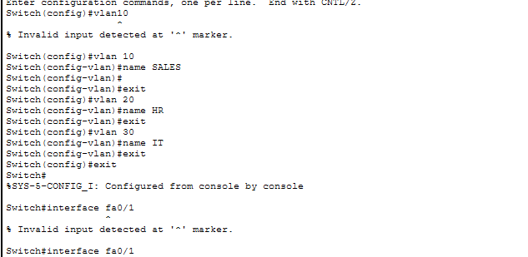

2. What is the purpose of a trunk link between the switch and router?
A trunk link is a connection configured to carry traffic for multiple VLANs simultaneously over a single physical cable. Without a trunk, the link would belong to only one VLAN, blocking traffic from all other departments.

3. Explain what a router sub-interface is and why it is used.
A sub-interface is a virtual interface created by dividing a single physical router port into multiple logical interfaces (like Fa0/0.10). It is used for "Router-on-a-Stick" configurations to allow a single router port to serve as the default gateway for multiple different VLANs at the same time
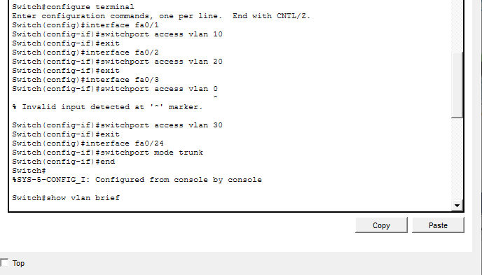
4. What would happen if the trunk port was not configured?
If the port connecting the switch to the router was left as an "Access" port (the default), it would only accept traffic for one specific VLAN (usually VLAN 1). Traffic from SALES (10), HR (20), and IT (30) would be dropped at the switch port because the tags would not be recognized, and Inter-VLAN routing would completely fail

PART 2: The Evidence
Provide screenshots showing successful pings between PCs in different VLANs
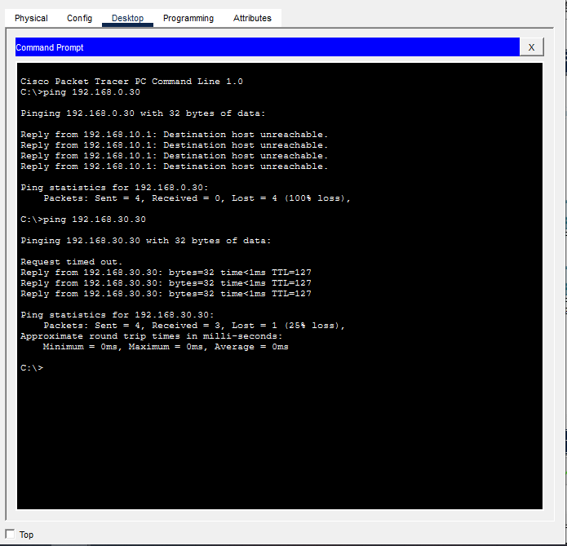
Figure 1 ping pc1 to pc3
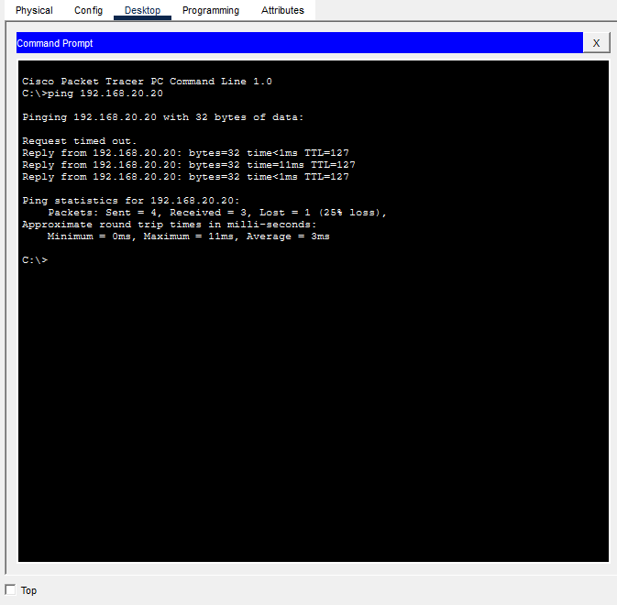
Figure 2ping from pc3 to pc2
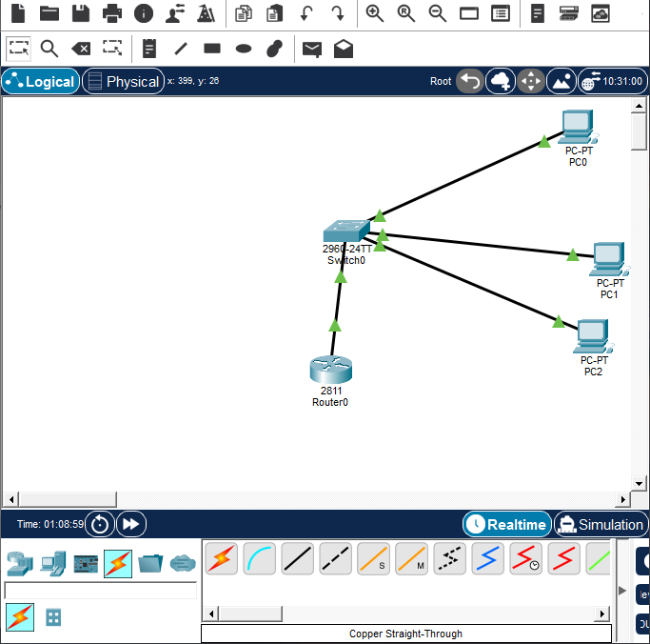
Figure 3setup

